# **EMBARKS SYSTEMATIC SAMPLING**

# Sheet 4

## Part A

1) Display letter of the word in Pattern4

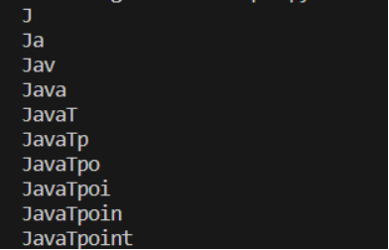

2) Implement a Python program to count the occurrences of each word in a given text.

## Part B

1)Reverse number pattern printing

5 4 3 2 1

4 3 2 1

3 2 1

2 1

1

2) Implement a Python program to find the longest palindrome substring in a given string.

## Part c)

1. Write a code to print all the prime numbers between 1 to n numbers.
2. Write a Python program to remove duplicates from a list while preserving the order of element